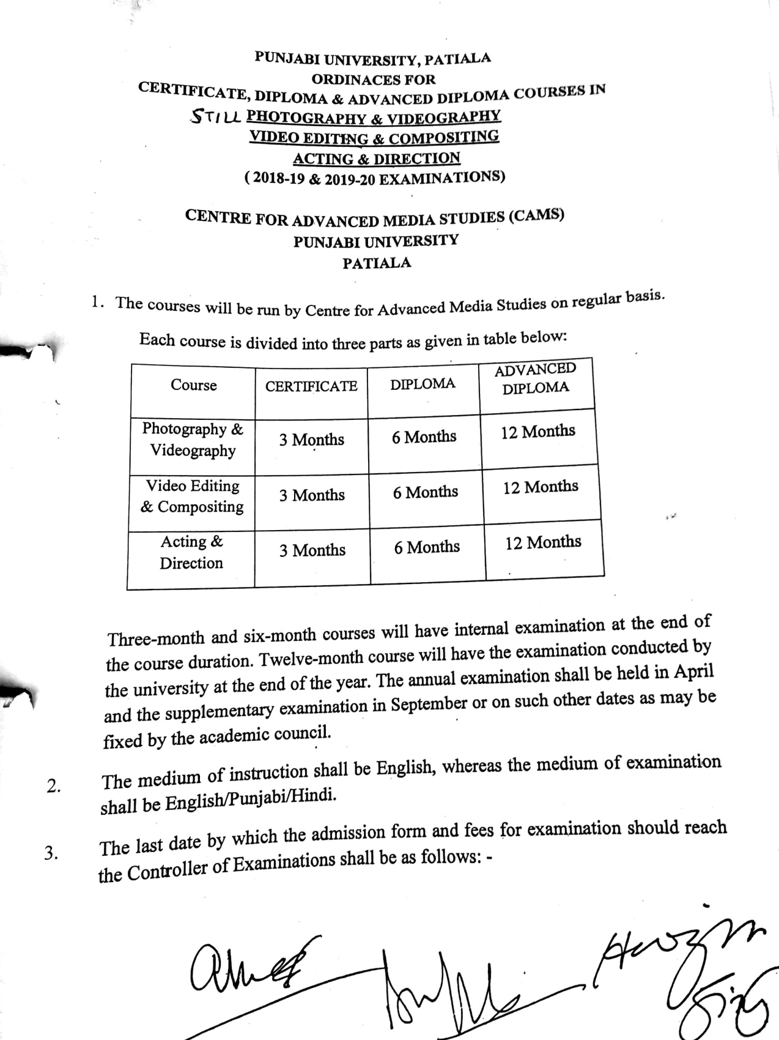

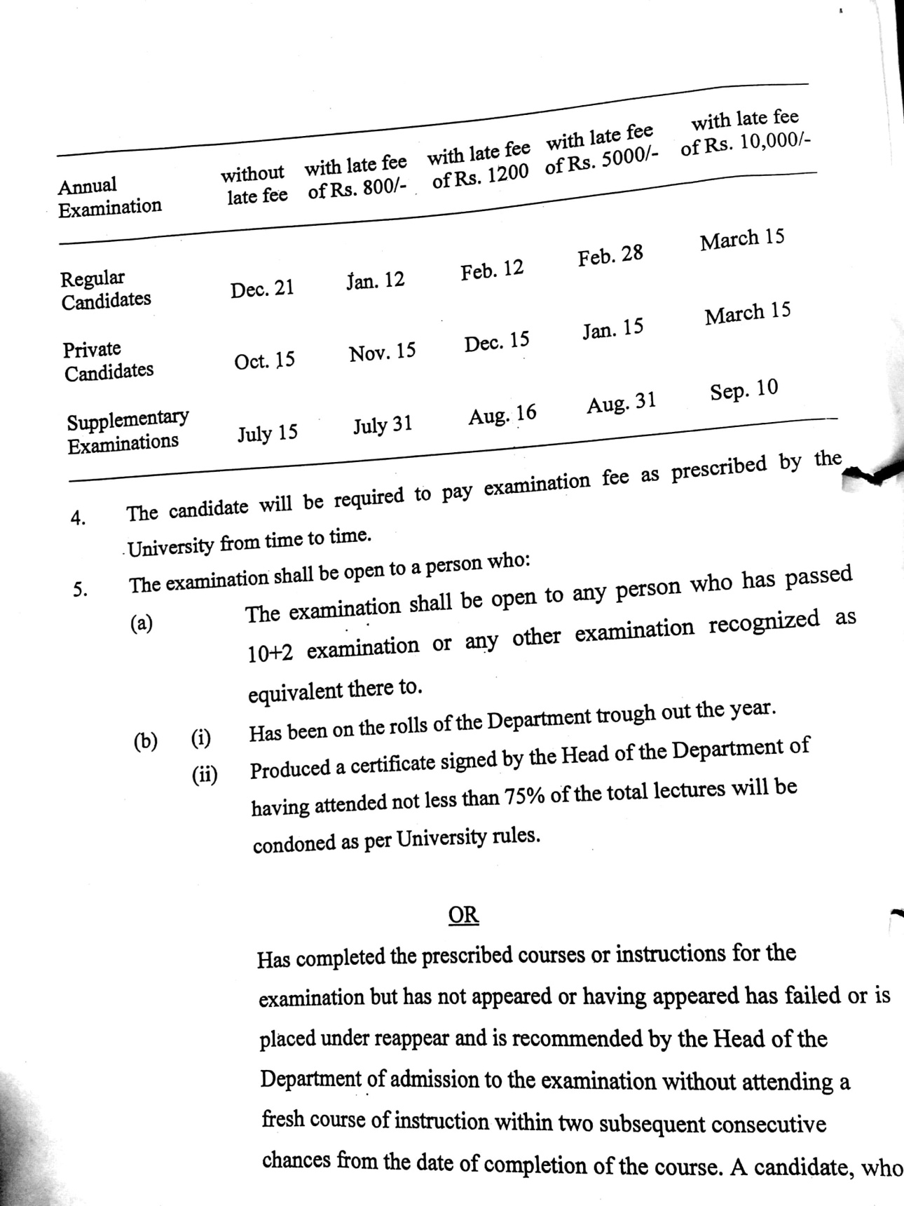

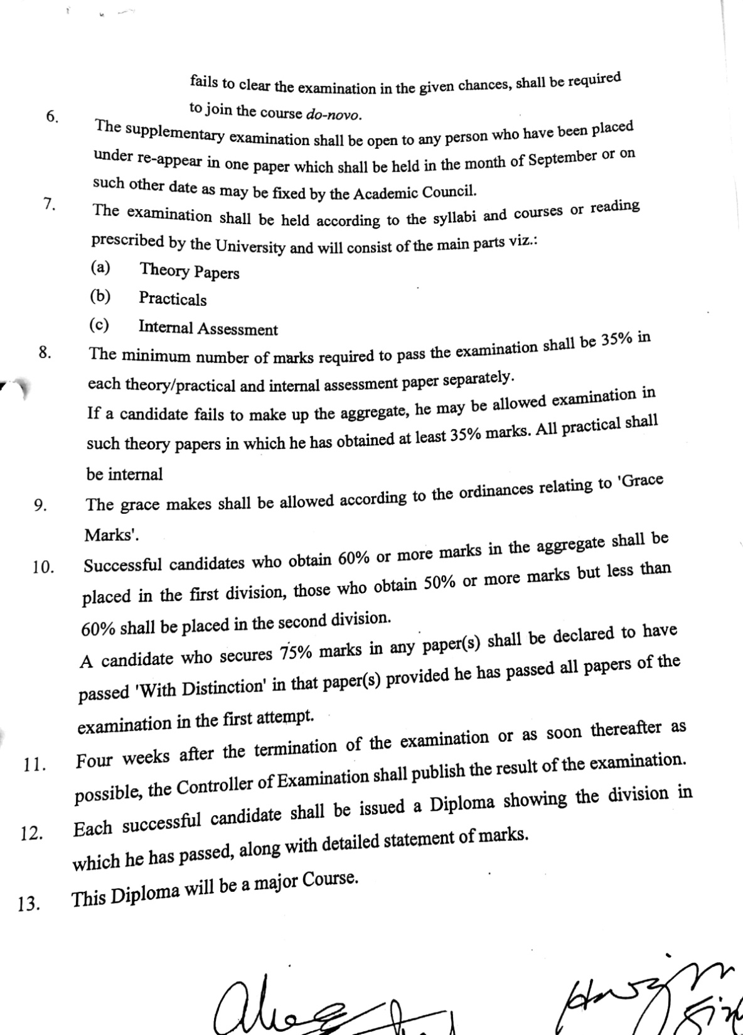

SYLLABUS

Short Term Evening Courses

SESSION: 2018–2019, 2019-20&
2020-21
ACTING AND DIRECTION

Paper : Acting & Direction (3 Months)

Paper : Acting and Direction (6 months)

PAPER : Acting & Direction (One Year)

Paper : Acting & Direction (3 Months)

Max. Marks: 100 Continuous Internal Evaluation 80 Marks
Pass Marks: 35 Internal Assessment 20 Marks

INSTRUCTIONS FOR THE CANDIDATES

Candidates will be required to submit assignments from each section and perform the tasks given by the teacher(s) during the entire period of the three months. Evaluation will be done on the basis of quality of assignments and viva voce. Each section will carry 10 marks.

Defining and understanding Acting; Acting as an essential aspect of life; Acting as an art of Communication; Is Acting mere believing! Acting for Theatre, TV & Films; Differences and similarities between Theatre and Film Acting; Theatre Games.
Defining and understanding Direction; Actor-Director relationship; Audition; Blocking; Improvisation; Characterisation; Visualisation and observation; Direction as continuous observation of life, life events and situations.
Practical/Tutorial: Making a documentary/Short fiction film/Docudrama; Theatre games for developing flexibility, improvisation etc.; Witnessing and Self-awareness exercises.
A viva-voce will be held to evaluate the films made by the students. Evaluation will be based on the following components: a) Production book and script b) Quality of Research c) Quality of Shoot and d) Editing. The duration of the project should be 2-5 Minutes. The Project should be submitted along with a Production Book comprising compilation of Proposal, Research, Budget, Treatment, Script, Screenplay, Storyboards, Breakdown Sheet.

Paper : Acting and Direction (6 months)

Max. Marks: 100 Continuous Internal Evaluation 80 Marks
Pass Marks: 35 Internal Assessment 20 Marks

INSTRUCTIONS FOR THE CANDIDATES

Candidates will be required to submit assignments from each section and perform the tasks given by the teacher(s) during the entire period of the three months. Evaluation will be done on the basis of quality of assignments and viva voce. Each section will carry 10 marks.

Deep understanding of course contents of Certificate course contents; Historical development of film stages; Historical development of cameras; Changing trends of film Acting as a consequence of technological developments; Sensory dynamics of Acting; Speech & Voice modulation.
Yoga & Meditation; Role of Yoga & Meditation in Acting& Direction; Spontaneity; Maintaining continuity; Script and Screenplay; Dubbing and lip-synching; Visualisation and observation.
Practical/Tutorial: Making a documentary/Short fiction film/Docudrama; Theatre games for developing flexibility, improvisation etc.; Witnessing and Self-awareness exercises.
A viva-voce will be held to evaluate the films made by the students. Evaluation will be based on the following components: a) Production book and script b) Quality of Research c) Quality of Shoot and d) Editing. The duration of the project should be 3-5 Minutes. The Project should be submitted along with a Production Book comprising compilation of Proposal, Research, Budget, Treatment, Script, Screenplay, Storyboards, Breakdown Sheet.

Paper : Acting & Direction (One Year)
Max. Marks: 100 Theory: 60 Marks
Pass Marks: 35 Practical: 20 Marks
Time Allowed: 3 Hours Internal Assessment: 20 Marks

INSTRUCTIONS FOR THE PAPER-SETTER

The question paper will consist of three sections: A, B and C. Sections A and B will have four questions from the respective sections of the syllabus and will carry 10 marks each. Section C will consist of 10 short-answer type questions which will cover the entire syllabus uniformly and will carry 20 marks in all.

INSTRUCTIONS FOR THE CANDIDATES

Candidates are required to attempt two question each from the sections A and B of the question paper and the entire section C.

Deep understanding of contents of Certificate and Diploma course contents; Stages of Film Production—Preproduction, Production and Postproduction; Sound; Lighting; Videoediting; Indoor and Outdoor shooting; Single and multi-camera shooting; Understanding Still and Video camera; Camera frames, angles and movements.
Location hunting; Budgeting; Approach & treatment; Role, duties and function of production executives; Breakdown sheet; Storyboard; Costume and stage crafting; Sets and properties; Idea and Shooting Scripts; Screenplay; Storyboards; Breakdown Sheet; Film promotion and marketing;Role of Director in maintaining relationship between Below-the-line and Above-the-line crews.
Practical/Tutorial: Making a documentary/Short fiction film/Docudrama; Theatre games for developing flexibility, improvisation etc.; Witnessing and Self-awareness exercises.
A viva-voce will be held to evaluate the films made by the students. Evaluation will be based on the following components: a) Production book and script b) Quality of Research c) Quality of Shoot and d) Editing

The minimum duration of the project should be 5 Minutes. The Project should be submitted along with a Production Book comprising compilation of Proposal, Research, Budget, Treatment, Script, Screenplay, Storyboards, Breakdown Sheet.

